PROGRAMMING FUNDAMENTAL

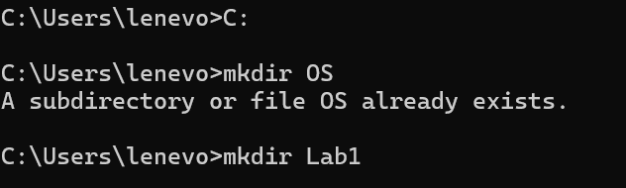
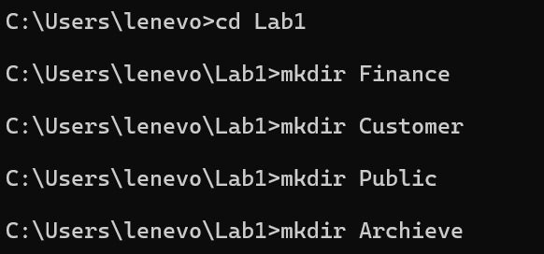

Step 1: Write Drive C and press enter.

Step 2: “mkdir” used to make a new folder and “cd” is used to change directory.

Step 3: Make subfolders of Public.

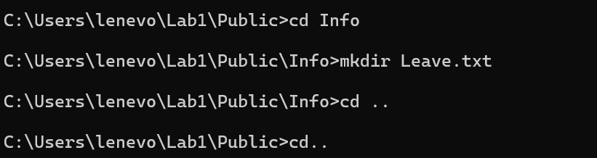

Step 3: Make subdirectory files.
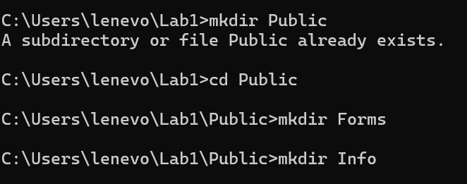

Step 3: make text in public subfolder.


Step 4: Make customer txt 1, 2 ,3.

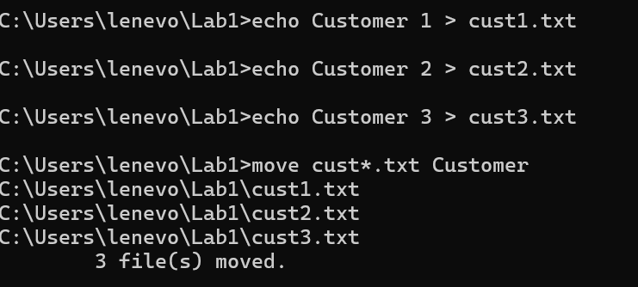

Step 5: copy of customer 1 2 3.

